WASHINGTON’S FAREWELL ADDRESS (1796)
What is it?

2 | 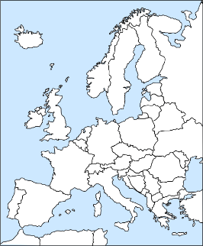 | 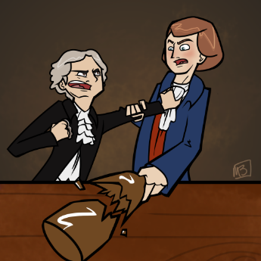 | 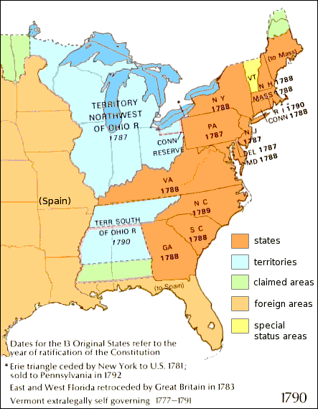  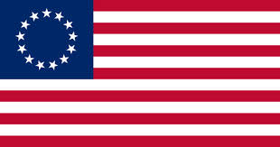
Main Idea: | Main Idea: | Main Idea: | Main Idea:

WASHINGTON’S FAREWELL ADDRESS (1796)
What is it?

2
Main Idea: | Main Idea: | Main Idea: | Main Idea:

